# auf logo blue colored-small.pngANGELES UNIVERSITY FOUNDATION

# *Angeles City*

**College of Computer Studies**

Center of Excellence in IT Education

PTF50-Professional Track 5

Student Name: **Decena, Stefen Genoa P.**  Date Submitted: **03/10/2022**

Course: **BSCS4** Submitted to: **Dr. James A. Esquivel**

Midterm Lab Quiz 3

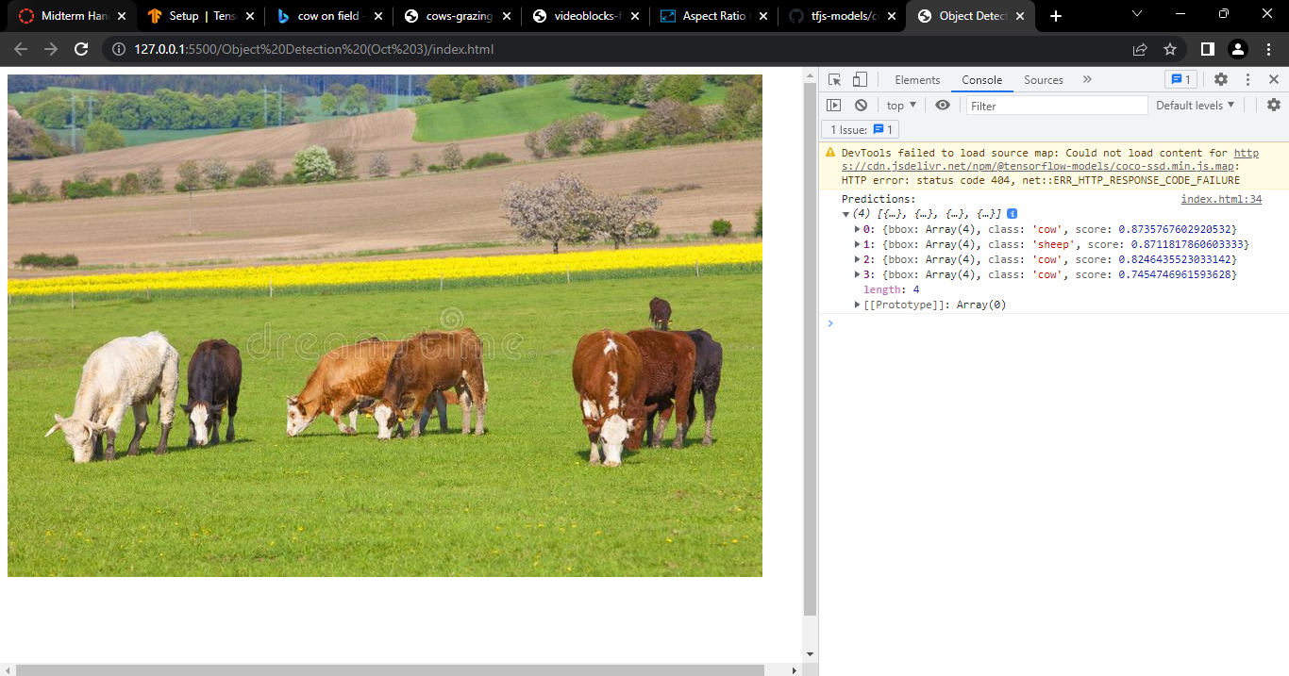

Predicting cows

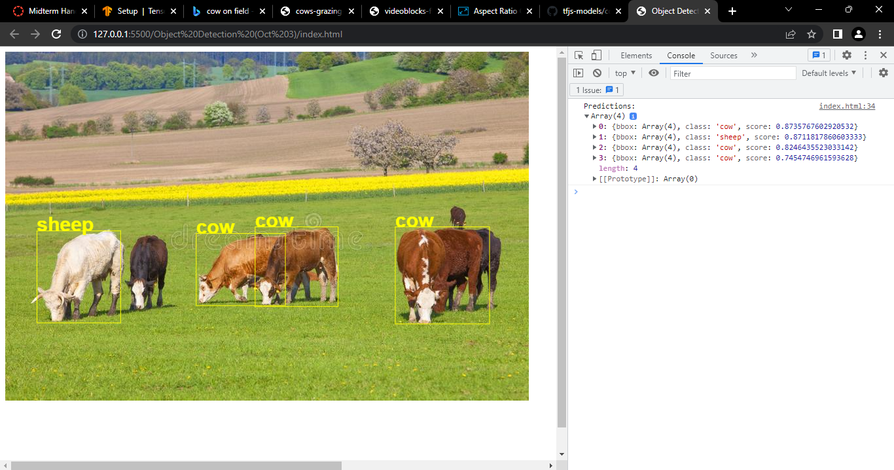

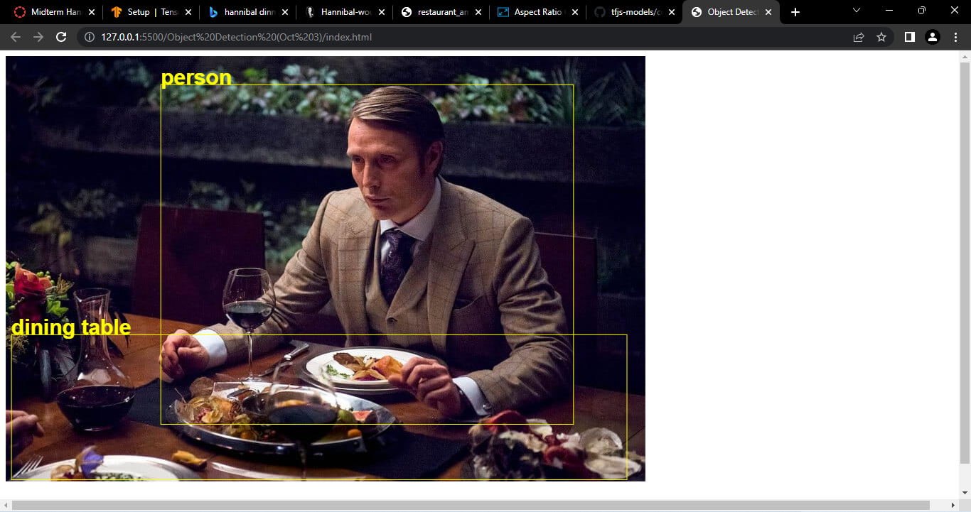

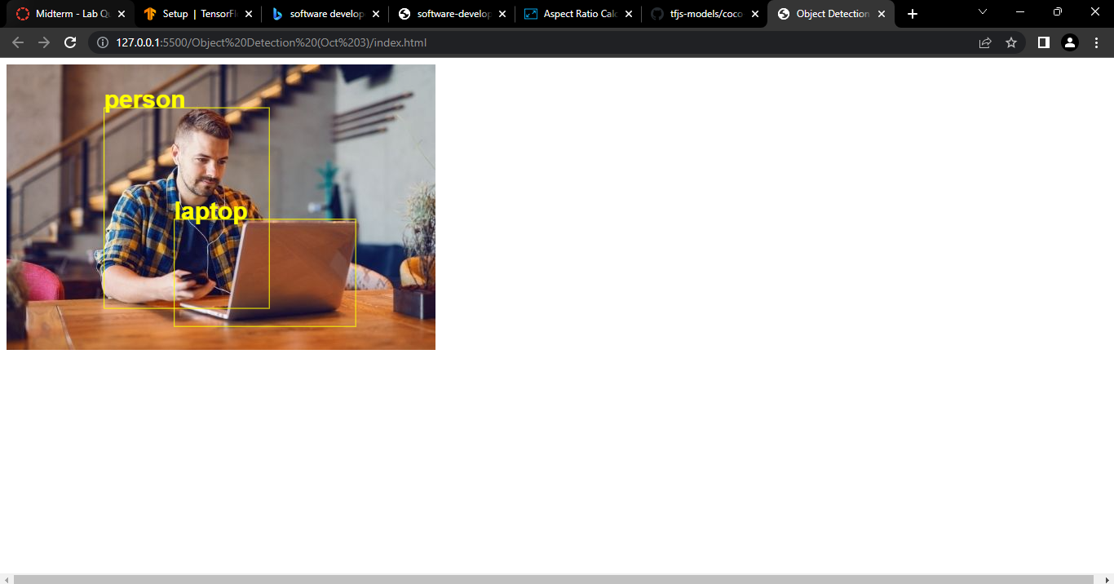

Prediction + outline of objects